**PROJECT DOCUMENTATION**

Project – Real Time Pizza Order Tracker

Made By – Shubham Kumar

Batch – TATA

------------------------------------------------------------------------------------I

I have made a Real-time pizza order tracker website. by using Java-script, Nodejs, express and have Mongo-db data base for this project.

The project will contain following features---

All the data will be stored in mongo DB database and will be retrieved from there only.

**Features:**

Project will have 2 types of user one will be the customer who can order pizza. And another will be the admin who will have access to all orders placed by the customer and admin will be responsible for fulfilling the the customers and updating the order details of the customers individually.

**Customer Do’s**

* Can login/register in the app.

Login

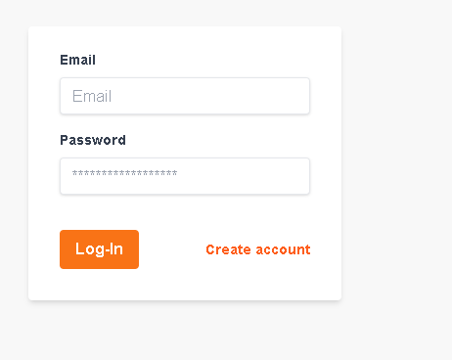

Register

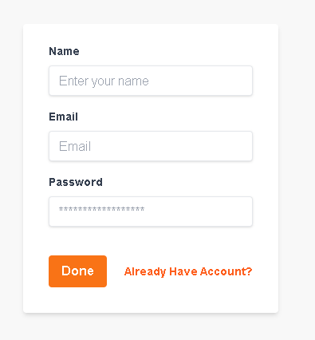

* Can Add items in the cart.

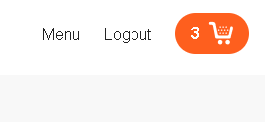

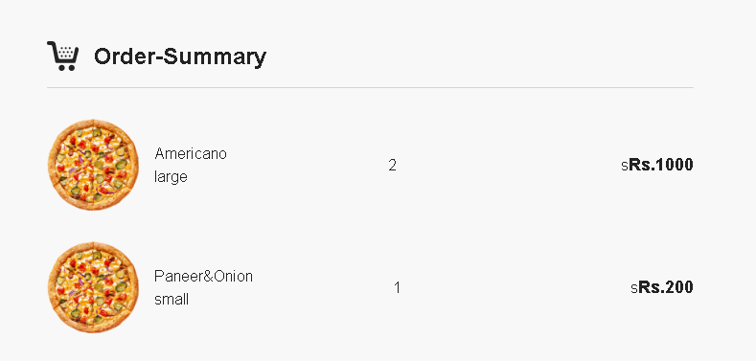

* Can Place order in the app.

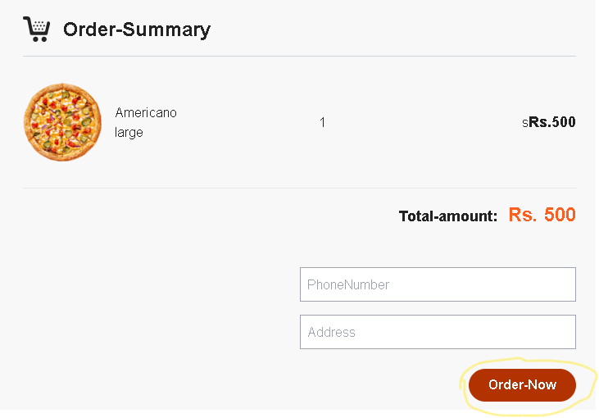

* Can see their full order history.

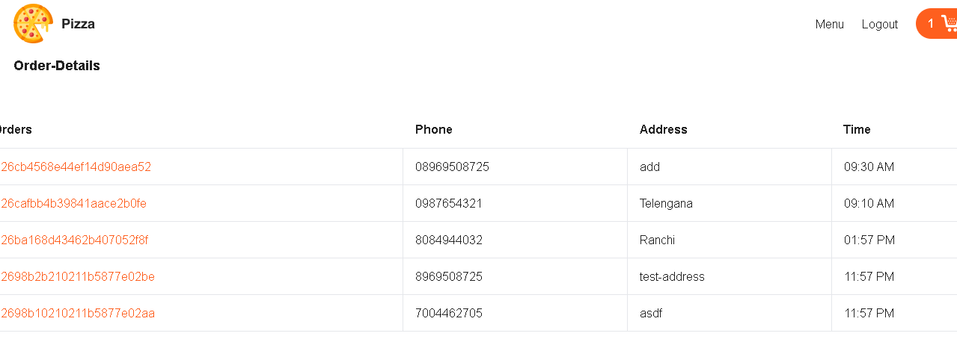

* Can Track Their current Order status.

**Customers Can’t**

* A customer cannot order pizza when he/she is not logged in.
* A customer cannot access admin order details page
* A customer cannot access other customer’s order details.

Coding and implementation pages are shown below-

* A properMVC project structure has been followed for this project.

